Additional file
Additional fig. 1. Map of the study area.

Additional fig. 2. The preferred habitat of Himalayan goral (Naemorhedus goral).

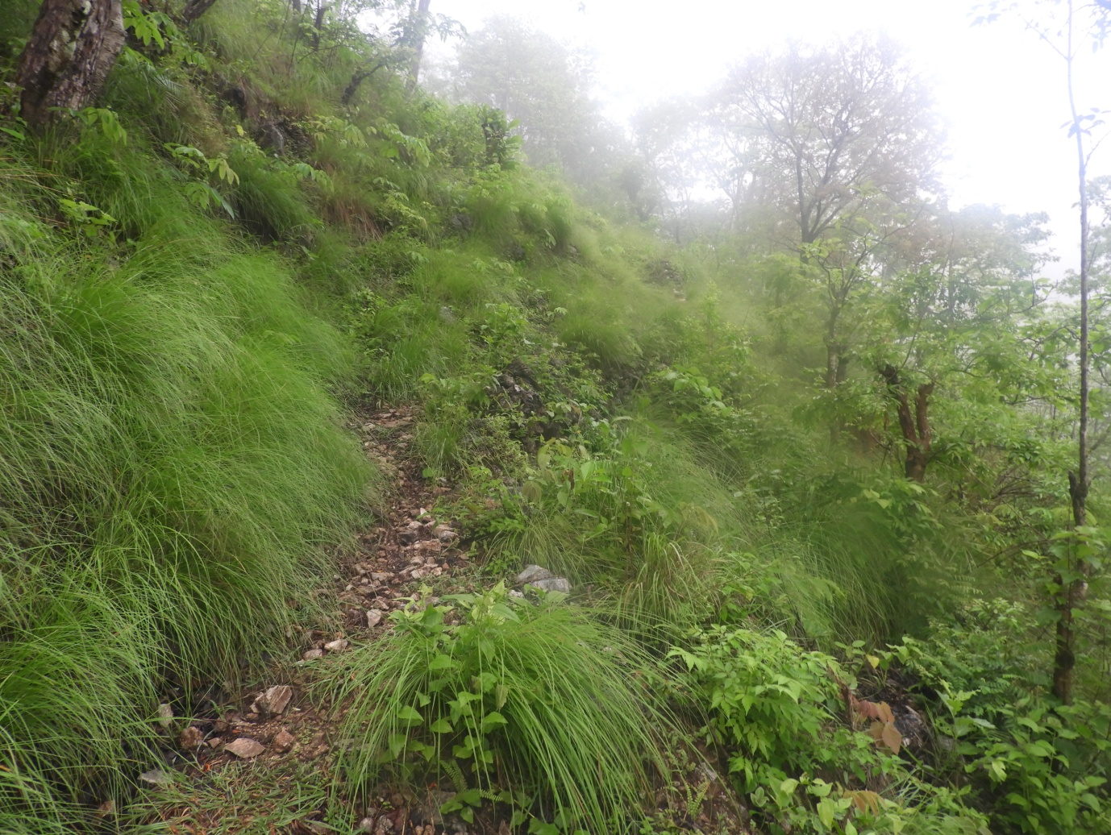

Additional fig. 3. The male Himalayan goral (Naemorhedus goral) recorded from Rumsi area, Tanahun, Nepal.

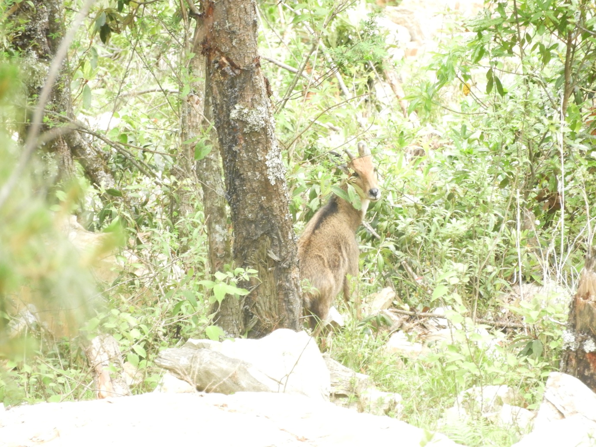

Additional fig. 4. The fresh dropping of Himalayan goral (Naemorhedus goral).
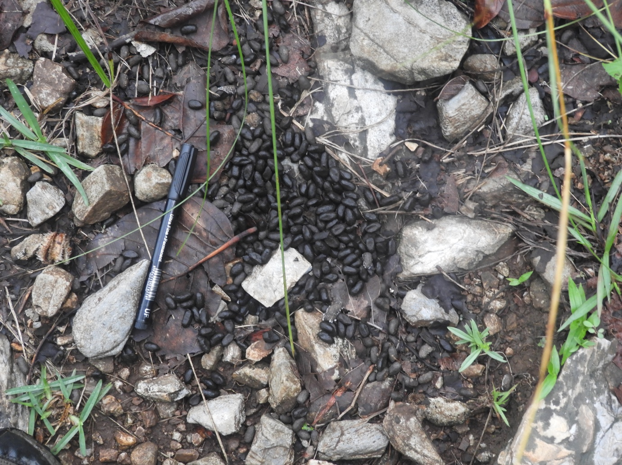

Additional fig. 5. Larva of Angiostrongylus sp. at Iodine staining (360X15µm, at 400x).

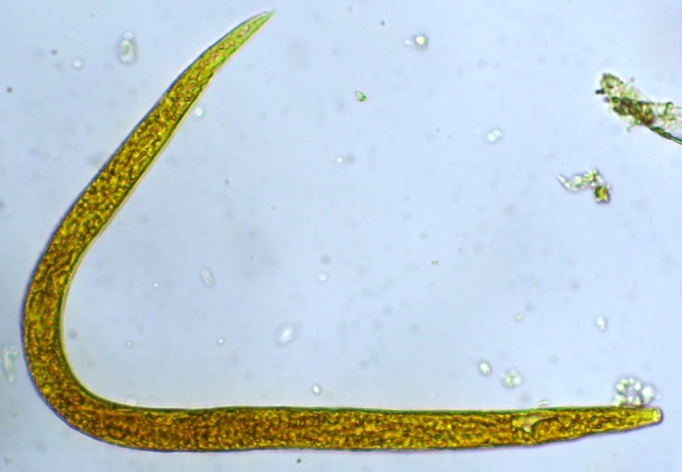

Additional fig. 6. Larva of Muellerius capillaris at potassium dichromate solution (268X12µm, at 400x).

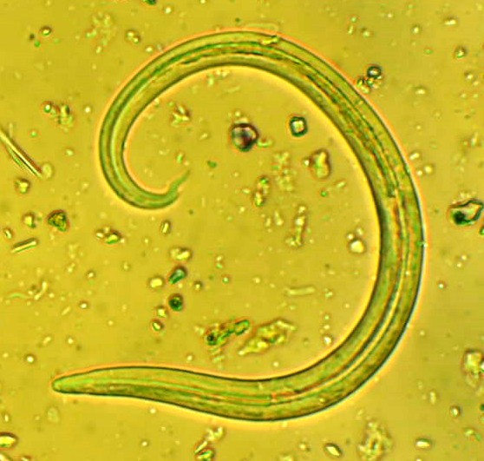

Additional fig. 7. Egg of a Strongyle at direct mount (88X55µm, at 400x).

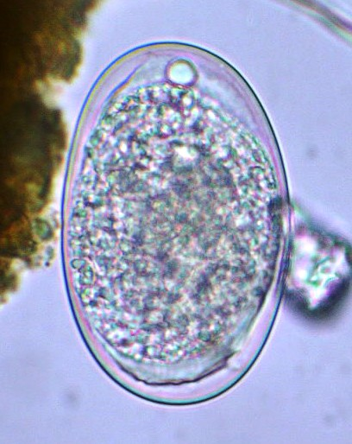

Additional fig. 8. Egg with larva of Spirocerca sp. at Iodine staining (55X19µm, at 400x).

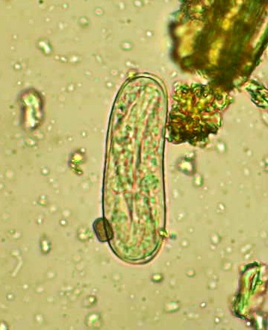

Additional fig. 9. Egg of Trichostrongylus sp. at direct mount (97X54µm, at 400x).

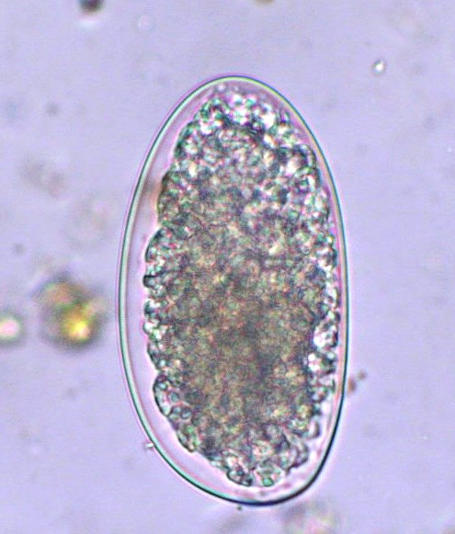

Additional fig. 10. Cysts of Entamoeba spp. at Iodine staining (8X8µm, at 400x).

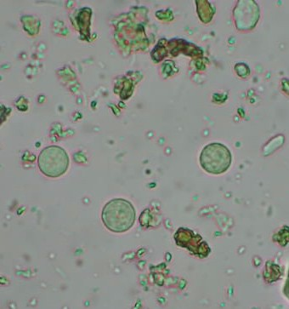

Additional fig. 11. Oocyst of Eimeria sp. after floatation (26X14µm, at 400x).

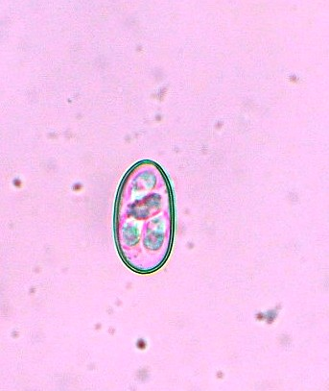

Additional fig. 12. Cyst of Blastocystis sp. at Iodine staining (19X17µm, at 400x).

